13.23: a) Setting 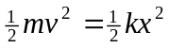 in Eq. (13.21) and solving for x gives 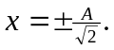 Eliminating x in favor of v with the same relation gives 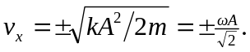 b) This happens four times each cycle, corresponding the four possible combinations of + and – in the results of part (a). The time between the occurrences is one-fourth of a period or

